Program Information | [Lesson Title]  House Transformations |  |  |  |  | TEACHER NAME |  |  | PROGRAM NAME
Program Information | [Unit Title] |  |  |  |  | NRS EFL(s)  3 – 4 |  |  | TIME FRAME  240 minutes
Instruction | ABE/ASE Standards – Mathematics
Instruction | Numbers (N) |  |  | Algebra (A) |  | Geometry (G) |  |  |  | Data (D)
Instruction | Numbers and Operation |  |  | Operations and Algebraic Thinking |  | Geometric Shapes and Figures |  | G.2.3, G.3.3, G.4.1, G.3.4 |  | Measurement and Data
Instruction | The Number System |  |  | Expressions and Equations |  | Congruence |  | G.4.5 |  | Statistics and Probability
Instruction | Ratios and Proportional Relationships |  |  | Functions |  | Similarity, Right Triangles. And Trigonometry |  |  |  | Benchmarks identified in RED are priority benchmarks. To view a complete list of priority benchmarks and related Ohio Aspire lesson plans, please see the Curriculum Alignments located on the Teacher Resource Center (TRC).
Instruction | Number and Quantity |  |  |  |  | Geometric Measurement and Dimensions
Instruction |  |  |  |  |  | Modeling with Geometry
Instruction | Mathematical Practices (MP)
Instruction | ☑ | Make sense of problems and persevere in solving them. (MP.1) |  |  |  | ☑ | Use appropriate tools strategically. (MP51)
Instruction | □ | Reason abstractly and quantitatively. (MP.2) |  |  |  | □ | Attend to precision. (MP.6)
Instruction | ☑ | Construct viable arguments and critique the reasoning of others. (MP.3) |  |  |  | ☑ | Look for and make use of structure. (MP.7)
Instruction | ☑ | Model with mathematics. (MP.4) |  |  |  | □ | Look for and express regularity in repeated reasoning. (MP.8)
Instruction | LEARNER OUTCOME(S)  - Students will plot points and segments on a coordinate plane.  - They will be able to complete partial 2-d figures on the coordinate plane as well as represent and analyze figures using the coordinate plane.  - Finally, students will be able to graph the results of translations, reflections, and rotations. |  |  |  |  | ASSESSMENT TOOLS/METHODS  - Each of the “you do” steps will serve as assessment. The instructor should be able to gauge understanding by having different students provide their solutions and explanations of how they arrived at that solution. In addition, during the “we do” steps, instructors should be encouraging all students to participate in the discussion. The ability to provide input in these discussions will help the teacher gauge each student’s mastery of the concepts.  - To do a final check on each student’s grasp of the concepts, have them work individually on the following to turn into you (if there is not sufficient time at the end of the lesson, have them bring it to turn in at the beginning of the next class): Have each student create their own furniture layout for a room in their house. This can be any room in the house, not necessarily the living room as in the lesson. Their room must have at least three pieces of movable furniture. The student must then move one piece of furniture using a translation, another piece using a reflection, and a final piece using a rotation. Have them turn in the following:  - On graph paper, they should have the initial layout of their room. On that same graph, they should notate the new positions of the three moved pieces of furniture (the markers would come in handy here).  - A description of each transformation. For example: a translation up 2 units and to the left 3 units, a reflection over the x-axis, or a rotation 270° about the origin.  - The coordinates of the corners of the pieces of furniture they’ll be moving before and after the transformation.
Instruction | LEARNER PRIOR KNOWLEDGE  - Mathin’ Around the House and Walking the Grid lessons
Instruction | INSTRUCTIONAL ACTIVITIES  Note: Keep in mind that your class may not need to go through each of the parts below. Please pick and choose which elements to incorporate into your actual lesson based on what you know of your students. In addition, extra sample problems may need to be incorporated based upon your particular class.  - Later in this lesson, we will be dealing with transformations. The context will be moving furniture around a home. In order to help plan out the transformations, we will “plot” the objects onto a coordinate plane. Placing things on a coordinate grid is not an uncommon task. The idea of graphing is used in construction and architecture to make sure objects are properly aligned. For our purposes, we must first be able to place objects on the grid. To do this, we must first be able to plot a point on a coordinate plane.  The coordinate plane was covered in an earlier lesson, but let’s explore it more here.  - Since our overall goal here is to be able to take a room and (mathematically) transform the items in it so that the layout is completely new, we want to know what the different transformations do as well as what the different symmetries mean for each object. Make sure everyone has a handout on Symmetries and Transformations. This will help with the vocabulary for the rest of the lesson. (Note: A possible point for discussion would be what sort of shapes have point symmetry? Since we’re looking for objects that are the same on both sides of the line, we need objects that already have 180° (or 2nd order) rotational symmetry.) We are going to start with checking symmetries of different shapes as this will help us with our transformations. It will help us know whether a rectangular coffee table, for example, will “look” the same once we rotate it. It will also tell us if we need to worry about certain pieces of furniture having a “front” side. If we reflect that, will the front stay in the front?  (I do) Using a blank coordinate grid (2 can be found at the end of the Symmetries and Transformations handout), let’s explore shapes and symmetries. If we think back to the shapes we know, we can work with squares, rectangles, and triangles rather easily. For our furniture, we will most likely have squares and rectangles. If needed, go back and review any properties of these shapes such as congruent sides, parallel sides, and perpendicular sides. Now, let’s say we have the following graph:  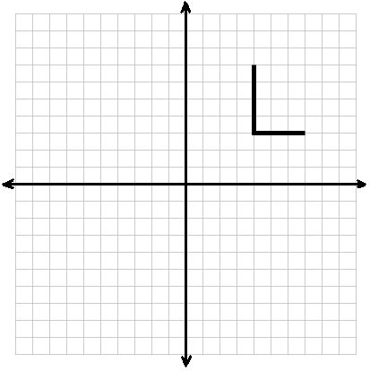  We have two segments, one that goes between (4,3) and (4,7) and one that goes between (4,3) and (7,3). We are told that this is two sides of a rectangle and are asked to complete the rectangle.  Given the graph, we must find the other 2 sides of our shape. We know that rectangles have opposite sides parallel and congruent and that there are four right angles. We also know that rectangles have two lines of reflection symmetry along the midpoints of the sides. We have a few options here. One is to find the length of one given side so that we know the length of the opposite side. Since we know we have only horizontal and vertical lines, it will be easy to make perpendicular/parallel lines. If we take the vertical side, we see its length is 4. Thus, I need a parallel side with length 4. This side will start from the other endpoint of the horizontal, bottom side. Once we draw that in, we have three of the 4 sides of our rectangle. Our final side just needs to attach the two free endpoints.  Another option would have been to use our patty paper to use reflection symmetry. Let’s use that method to check our answer. If we take a piece of patty paper and trace the “L” shape we started with onto it, we can now work with it. Picking it up, if we fold along the midpoint of one of the sides (so that both pieces of the segment match up on either side of our fold), we have found a line of reflection symmetry in our shape. Now, we must just copy the complete side from one side of our fold to the other. We can then do this once more folding along the midpoint of the other sides.  Answer: 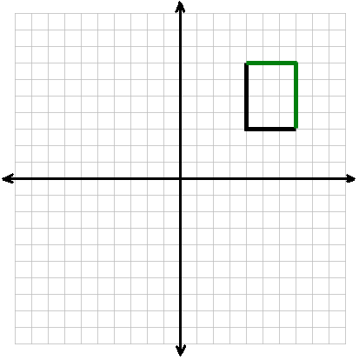  (We do) Have the students walk you through what to do for the following image if you are only told that this is the bottom-most side of a square:  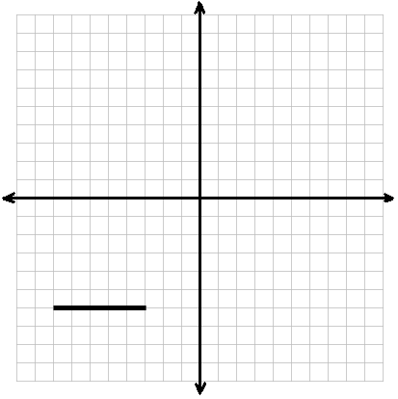  Since the segment goes from (-8,-6) to (-3,-6), we know the side length for our square is 5. Since we have a horizontal line segment, perpendicular lines will be vertical. We need vertical segments from each endpoint of the given segment that are each 5 units in length. Once we draw those in, we will only need to attach the two free endpoints at the top of these vertical segments.  Answer: 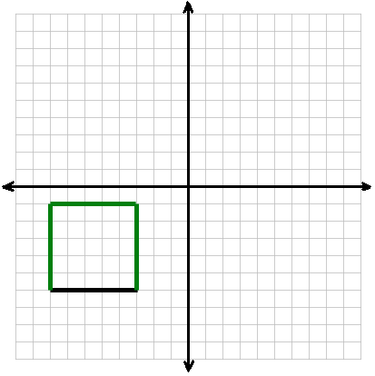  (You do) Have the students work on what to do to complete this image. You are told that the shape has both rotational and reflection symmetry. (The segment extends from (-2,2) to (2,2).)  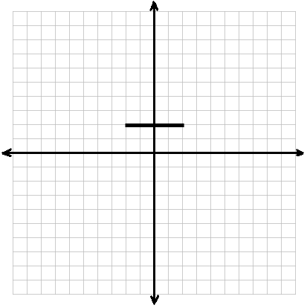  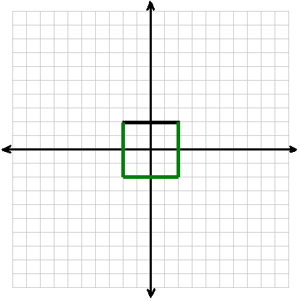  Following this first activity, bring everyone together for a small discussion. Before we start moving furniture, discuss how this idea of symmetry will have an effect on moving objects. If a square table has rotational symmetry, will it matter which direction it is facing? Why or why not? Will it matter if I flip or rotate it vs. just translating it? What if this square table now has a drawer on only one side? Does it still have rotational symmetry? Is it the exact same on all sides? What transformations does this have an impact on?  - Now we’re going to move to the transformations themselves. The first one is translation. A translation should be introduced as synonymous with the word “slide.” If we could tangibly slide an object in the coordinate plane to any other position in the plane without changing the orientation of the object, this would be a translation. If students do not already have the SmartPal kits, the Room Layouts handout, and some patty paper, they will need those now.  (I do) Looking at the Room Layout handout, show students how to do a translation using the entertainment center from the living room.  Due to a mistake on the part of the movers, the Harrisons need to move their furniture around. In the living room, nothing needs reoriented, or turned, but things do need pushed backwards for walking space. We want to change the coordinates of every piece of furniture, starting with the entertainment center, so that there is space from the door. We are told at the top of the page that each square on the picture represents a half foot, or 6 inches. Currently, the entertainment center has its corners at (-10,4), (10,4), (10,0), and (-10,4). (Note: Numbers were put in the corners of one object in each room for both the before pictures and the answer pictures. This was done in case teachers want students to be on the same page with what their “first corner” is each time. For the before pictures, the upper left corner was always labeled “1”, and the other corners were then subsequently labeled in a clockwise fashion. For the answer pictures, the corners are labeled so that “1” is the image of that first corner from the before picture. It is up to you whether you use this or not, it is not necessary.)  Since we have the patty paper as a tool, we will use it to copy the object we are moving and then physically manipulate its position. If we overlay the piece of patty paper over the before image, we can trace the entertainment center. Next, we are told that everything must go back 3 feet. “Back” in our picture means moving directly upward. Since our grid has spaces that represent 1/2 foot, 3 feet would then be 6 spaces. So we need to move our entertainment center up 6 spaces. If we slide the patty paper up the desired number of spaces, we should end up with it against the very top row on our grid. Now that we see where is should end up, we can fill in its new position on the blank graph. From there, we can find its new coordinate points. (Since we did not change the orientation at all, the corners are still in the same order with “1” in the top left and the rest going clockwise.) Our new coordinates are: (-10,10), (10,10), (10,6), and (-10,6).  If we take a step back and think about what we did graphically, we shifted something up on our grid by 6 spaces. On a coordinate plane, the vertical direction corresponds to the y-value, or the second number in our ordered pair. We did not change anything in the horizontal, or x-direction. So, it seems like our points should all change by adding 6 (moving upwards - the positive direction - along the y-axis) to the y-values. If we look at how our corner coordinates change, we see that we added 6 to the y-values for all four corners. Thus, our answer makes sense.  (We do) Have the students walk you through doing another piece of furniture. For example, if choosing the coffee table, they will first need to find the corner points (if they haven’t already). For the coffee table, those are (-3,-1.5), (3,-1.5), (3,-3.5), and (-3,-3.5). After copying the coffee table to the patty paper and shifting it up 6, we should have new coordinates at (-3,4.5), (3,4.5), (3,2.5), and (-3,2.5).  (You do) Have students complete the other furniture pieces (at least one) on their own.  - Our next transformation is a reflection. If a translation=a slide, a reflection=a flip.  (I do) Looking at the Room Layout handout, show students how to do a reflection using the TV stand from the bedroom.  Due to another mistake on the part of the movers, the Harrisons need to move their furniture around in their bedroom as well. Here, the Harrisons want their bed on the other side of the room. However, if they just translate it, as they did with the furniture in the living room, the bed will be facing the wall. They want the headboard against the wall, instead, so a translation will not work. We want to change the coordinates of every piece of furniture, starting with the TV stand, so that the objects in the room are directly across the room from where they are now. Since we want things to be “across” from each other, we want to flip, or reflect, the furniture in this room. The coordinates of the TV stand are currently (-3,10), (3,10), (3,7), and (-3,7). (Note: While a reflection will flip the room as we are describing, we need to be a little lenient of the fact that an actual “flip” would place all the objects facedown. If students bring this up, and ask why we didn’t just rotate the furniture, that could lead into Part 4.)  Since we have the patty paper as a tool, we will use it to copy the object we are moving and then physically manipulate its position. If we overlay the piece of patty paper over the “Before” image, we can trace the TV stand. Since we need a line of reflection this time, let’s also trace the x-axis since that is what we are reflecting everything over. Next, pick up the patty paper and fold it along this line of reflection. Lay the now folded piece of patty paper back where it was. Our x-axis should be lined up with the folded axis on our patty paper, and the patty paper (both halves as it is folded) should be over top of the bottom half of the graph. This will show us where the dresser will go after reflecting it. Note its position and place it on the blank graph. Our new coordinates are: (-3,-10), (3,-10), (3,-7), and (-3,-7).  Let’s once again think about this from a graphing perspective. Once more, we changed the furniture’s vertical position but not its horizontal position. We also changed the vertical orientation, or whether it was facing top or bottom, but not its horizontal orientation. As such, our x-values should not change. And between our starting coordinates and our ending coordinates, we see this to be the case. The y-values, however, should change. We flipped over the x-axis. As reflections preserve distance (as stated on the handout Symmetries and Transformations), then whatever distance we had between the x-axis and a point before reflecting it should still be the distance between the x-axis and that point after reflecting it. So, a point with a y-value of 10 prior to a reflection over the x-axis should have a y-value of -10 afterwards. Comparing our points, we see that all of our y-values have this property intact, so our new coordinates do make sense.  (We do) Have the students walk you through doing another piece of furniture. For example, if choosing the bed, they will first need to find the corner points (if they haven’t already). For the bed, those are (-5,3), (4,3), (4,-9), and (-5,-9). After copying the bed to the patty paper and reflecting it, we should have new coordinates at (-5,-3), (4,-3), (4,9), and (-5,9).  (You do) Have students complete the other furniture pieces (at least one) on their own.  - Our final transformation is a rotation. The word to help remember rotations would be “turn.”  (I do) Looking at the Room Layout handout, show students how to do a rotation using the desk from the office.  The movers made a final mistake and the Harrisons need to move their furniture around one more time. In the office, Mr. Harrison wants to shift everything around one wall to the left (counterclockwise). If he shifts everything using translations, nothing will face the right way. If he uses a reflection, some things will move two walls, while others will not change walls at all. Instead, he will use a rotation. If he wants to shift everything one wall to the left in a square room, that will be a 90° rotation. Currently, the desk has its corners at (-4,10), (4,10), (4,6), and (-4,6).  Since we have the patty paper as a tool, we will use it to copy the object we are moving and then physically manipulate its position. If we overlay the piece of patty paper over the “Before” image, we can trace the desk. Next, we are told that everything must rotate 90° counterclockwise about the center of the room. This makes the center of the room our point of rotation. If we place our finger on the origin, or “center of the room”, we can then rotate the patty paper about this point while leaving the original graph in place. Once we move the paper a quarter turn (90°) counterclockwise, note the new position of the desk. Our new coordinates are: (-10,-4), (-10,4), (-6,4), and (-6,-4). This time, we clearly see we changed both the x- and y- values, which makes sense as we changed the orientation and positioning of our object. We can use our Slide N’ Measure’s to check our rotation, though. If we make a line from any point on the desk before the rotation to the origin, and then make a line from that point’s position in our rotated image to the origin, we will have formed an angle. That angle should be 90° when we measure it. If it is, we have done our rotation correctly.  (We do) Have the students walk you through doing another piece of furniture. For example, if choosing the bookcase, they will first need to find the corner points (if they haven’t already). For the bookcase, those are (-10,7), (-6,7), (-6,-7), and (-10,-7). After copying the coffee table to the patty paper and shifting it up 6, we should have new coordinates at (-7,-10), (-7,-6), (7,-6), and (7,-10).  (You do) Have students complete the other furniture pieces (at least one) on their own.  Note: A question after these activities might be whether or not the students were able to find the coordinates using symmetry (as in the first activity) or if they just looked at the graph to find all four points. In addition, if time permits, it may be a good idea to see if students can find an object’s translation or reflection using just coordinates and no graph. Or, if they can figure out the rules for how the coordinates change for rotations of different angles around the origin. |  |  |  |  | RESOURCES  SmartPal kit  - Inserting a blank sheet of paper into the sleeves will give students a reusable sheet of paper that they can quickly try answers out on and erase without using up a pencil eraser. It’s quicker as well. For this lesson, we will want the grid handout provided inserted.  Student copies of Symmetries and Transformations (attached)  Blank coordinate grids for student use  Student copies of Room Layouts (attached)  Patty Paper (the kind of paper used to separate hamburger patties) for student use
 | DIFFERENTIATION
Reflection | TEACHER REFLECTION/LESSON EVALUATION
Reflection | Additional Information  Next Steps  Lines of reflection other than the two axes and points of rotation other than the origin. In addition, transformations can be done solely algebraically using functions. After working with the coordinate plane, it would be a good time to introduce graphing equations and functions.  Purposeful/Transparent  Students want to be able to apply the concepts of translations, rotations, and reflections into a real-world problem. Teachers will model and then guide them in using these concepts with respect to moving objects around the home.  Contextual  Transformations are normally difficult to put into a real-world context for many students. Many do not see the application outside of the coordinate plane. However, moving objects, like furniture, is one way to put this in context. Movers and contractors use the idea of rotations and translations and the fact that length is preserved when moving objects around inside a house to make sure they have enough room. Artists often use all three transformations in works of art. Basketball, pool, and mini golf all use the concept of a reflection and its ability to preserve angles when the ball bounces off the backboard or the railing.  Building Expertise  In geometry and algebra, the coordinate plane is extremely important. This lesson should further each student’s familiarity and comfort with the coordinate plane. In addition, recognizing that one shape is just a transformation of another shape will come in handy when working with similar and congruent shapes.
Symmetries and Transformations
Symmetry in the Coordinate Plane
Symmetry is a geometric property of an object. Two shapes are said to be symmetric if one is obtained from performing transformations on the other. However, shapes can have internal symmetry as well.
Reflection Symmetry
In this type of symmetry, a line can be drawn across a shape so that if we fold our shape along that line, the two sides will match up perfectly. This line that we fold on is called the line of reflection. It is possible for a shape to have more than one line of reflection, one line of reflection, or no lines of reflection. In the images below, lines of reflection, if they exist, are shown for different objects.
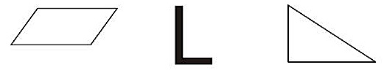
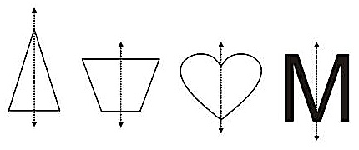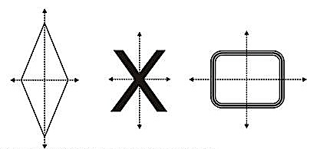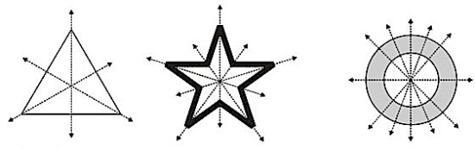

Rotation Symmetry
For rotational symmetry, the idea is that a shape will be exactly the same as its original image if we rotate it around a point. For shapes, often we will choose the center point for this. Then, if we hold the center point, and rotate the shape 360°, how many times will the shape be congruent to the original? For example, in the image below, if we rotate the equilateral triangle around its center, it will match up to the original three times and have rotational symmetry of order 3. The pentagon will do this five times, so will have order 5. Any shape will do it once, namely when we hit 360°, so any figure has rotational symmetry of order 1. However, we are more interested in shapes that are the same before we get all the way around to 360°.
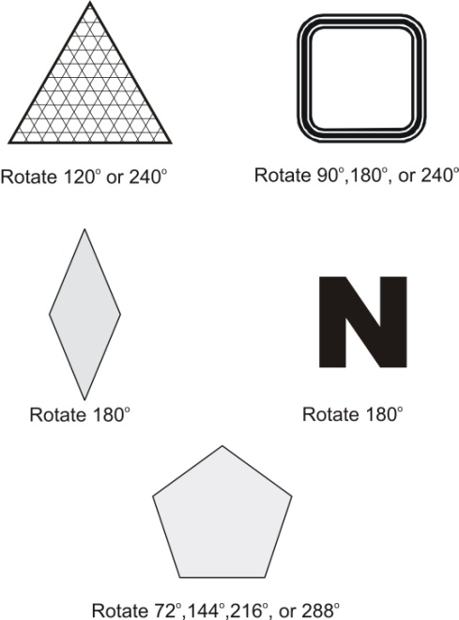
Transformations in the Coordinate Plane
In general, a transformation takes an object and moves it to a new position. If we move a point P, we typically label the point as P’ after the transformation.
Translations
- A translation “slides” an object to a new position in the coordinate plane.
- Translations preserve the following properties:
  - Distance: Lengths in the original are preserved in the translation. (For example: A side length in equilateral triangle ABC is 5. When we translate this, we will now have equilateral triangle A’B’C’ with side length 5.)
  - Angle measures
  - Parallel lines will still be parallel if translated.
  - Midpoints
  - Co-linearity
  - Orientation: The order of labeling is preserved.
Reflections
- A reflection is a “flip” or a mirror image of an object over a line in the coordinate plane.
- The distance from the object being reflected to the line of reflection is the same as the distance from the reflected object to the line of reflection.
- Reflections preserve the following properties:
  - Distance
  - Angle measures
  - Parallel lines will still be parallel if translated.
  - Midpoints
  - Co-linearity
- It is important to note that while the two objects will be congruent, the labeling order is not preserved in reflections. As this is a mirror image, the labeling order is reversed.
- The two most common lines of reflection in the coordinate plane are the x-axis and the y-axis. It is possible to reflect over any line, however.
Rotations
- A rotation is a “turning” of an object about a point of rotation in the coordinate plane.
- The angle formed between the original point and its rotated image is the angle of rotation. (Note: if the object rotated is a shape, the angle of rotation will be the same between all corresponding points—the original point and its rotated image.)
- Angles measured in the counter-clockwise direction are positive while angles measured in the clockwise direction are negative.
- Rotations preserve the following properties:
  - Distance
  - Angle measures
  - Parallel lines will still be parallel if translated.
  - Midpoints
  - Co-linearity
  - Labeling order is preserved.
- The most common point of rotation is the origin and the three most common angles of rotation in the coordinate plane are 90°, 180°, and 270°. With a protractor, however, we could do a rotation of any angle.

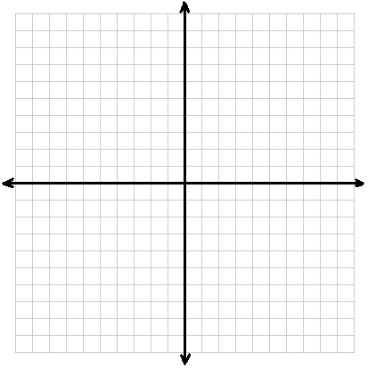
Room Layouts
After moving into a new house, the Harrisons realize the moving company did not put their furniture where they wanted it. Help them figure out what their rooms will look like with the following transformations. (***The distance between gridlines is 1/2 foot.)
Living Room (Before)
Find the four corner points of each piece of furniture in the diagram below:
Piece of Furniture | Corner 1 Coordinates | Corner 2 Coordinates | Corner 3 Coordinates | Corner 4 Coordinates
Entertainment Center
Coffee Table
End Table
Sofa
End Table
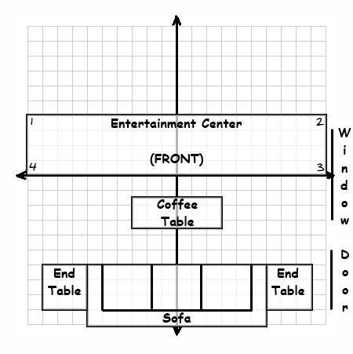

Living Room (Translation)
In order to create a space to walk into the home from the door, the Harrisons decide to move all the furniture back 3 feet until the Entertainment center is against the wall. Find the four corner points of each piece of furniture in the new setup:
Piece of Furniture | Corner 1 Coordinates | Corner 2 Coordinates | Corner 3 Coordinates | Corner 4 Coordinates
Entertainment Center
Coffee Table
End Table
Sofa
End Table
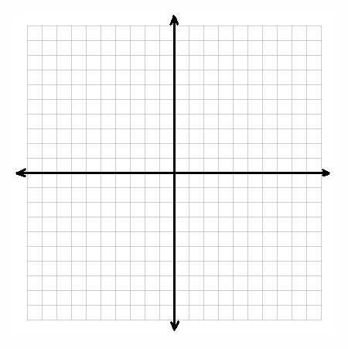

Bedroom (Before)
Find the four corner points of each piece of furniture in the diagram below:
Piece of Furniture | Corner 1 Coordinates | Corner 2 Coordinates | Corner 3 Coordinates | Corner 4 Coordinates
TV Stand
Bed
Night Stand
Dresser

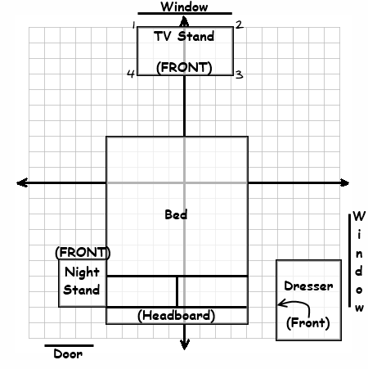

Bedroom (Reflection)
Upon entering the bedroom, the Harrisons once again see room for change. This time they know they don’t want the bed to be on the same side of the room as the door. They want the TV stand where the bed is and the bed where the TV stand is. Mrs. Harrison says this seems like a reflection. If they reflect all the furniture over the horizontal “center line” of the room, find the four corner points of each piece of furniture in the new layout:
Piece of Furniture | Corner 1 Coordinates | Corner 2 Coordinates | Corner 3 Coordinates | Corner 4 Coordinates
TV Stand
Bed
Night Stand
Dresser

Office (Before)
Find the four corner points of each piece of furniture in the diagram below:
Piece of Furniture | Corner 1 Coordinates | Corner 2 Coordinates | Corner 3 Coordinates | Corner 4 Coordinates
Desk
Bookcase
Lamp
Chair
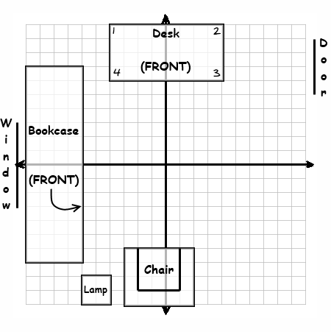
Office (Rotation)
Just like the previous two rooms, the Harrisons want to make some updates in the office as well. Mr. Harrison does not like the bookcase in front of the window taking up all the light. He wants to put his desk there, instead. In fact, he seems to just want to shift everything around the room by one wall. Find the four corner points of each piece of furniture in the new layout if they rotate everything around the center of the room counterclockwise by 90 degrees:

Piece of Furniture | Corner 1 Coordinates | Corner 2 Coordinates | Corner 3 Coordinates | Corner 4 Coordinates
Desk
Bookcase
Lamp
Chair
Room Layouts

After moving into a new house, the Harrisons realize the moving company did not put their furniture where they wanted it. Help them figure out what their rooms will look like with the following transformations. (***The distance between gridlines is 1/2 foot.)

Living Room (Before)
Find the four corner points of each piece of furniture in the diagram below:
Piece of Furniture | Corner 1 Coordinates | Corner 2 Coordinates | Corner 3 Coordinates | Corner 4 Coordinates
Entertainment Center | (-10,4) | (10,4) | (10,0) | (-10,0)
Coffee Table | (-3,-1.5) | (3,-1.5) | (3,-3.5) | (-3,-3.5)
End Table | (-9,-6) | (-6,-6) | (-6,-9) | (-9,-9)
Sofa | (-6,-6) | (6,-6) | (6,-10) | (-6,-10)
End Table | (6,-6) | (9,-6) | (9,-9) | (6,-9)

Living Room (Translation)
In order to create a space to walk into the home from the door, the Harrisons decide to move all the furniture back 3 feet until the Entertainment center is against the wall. Find the four corner points of each piece of furniture in the new setup:
Piece of Furniture | Corner 1 Coordinates | Corner 2 Coordinates | Corner 3 Coordinates | Corner 4 Coordinates
Entertainment Center | (-10,10) | (10,10) | (10,6) | (-10,6)
Coffee Table | (-3,4.5) | (3,4.5) | (3,2.5) | (-3,2.5)
End Table | (-9,0) | (-6,0) | (-6,-3) | (-9,-3)
Sofa | (-6,0) | (6,0) | (6,-4) | (-6,-4)
End Table | (6,0) | (9,0) | (9,-3) | (6,-3)
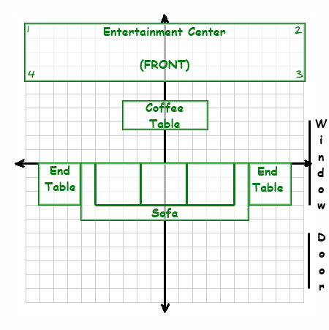

Bedroom (Before)
Find the four corner points of each piece of furniture in the diagram below:
Piece of Furniture | Corner 1 Coordinates | Corner 2 Coordinates | Corner 3 Coordinates | Corner 4 Coordinates
TV Stand | (-3,10) | (3,10) | (3,7) | (-3,7)
Bed | (-5,3) | (4,3) | (4,-9) | (-5,-9)
Night Stand | (-8,-5) | (-5,-5) | (-5,-8) | (-8,-8)
Dresser | (6,-5) | (10,-5) | (10,-10) | (6,-10)

Bedroom (Reflection)
Upon entering the bedroom, the Harrisons once again see room for change. This time they know they don’t want the bed to be on the same side of the room as the door. They want the TV stand where the bed is and the bed where the TV stand is. Mrs. Harrison says this seems like a reflection. If they reflect all the furniture over the horizontal “center line” of the room, find the four corner points of each piece of furniture in the new layout:
Piece of Furniture | Corner 1 Coordinates | Corner 2 Coordinates | Corner 3 Coordinates | Corner 4 Coordinates
TV Stand | (-3,-10) | (3,-10) | (3,-7) | (-3,-7)
Bed | (-5,-3) | (4,-3) | (4,9) | (-5,9)
Night Stand | (-8,5) | (-5,5) | (-5,8) | (-8,8)
Dresser | (6,5) | (10,5) | (10,10) | (6,10)
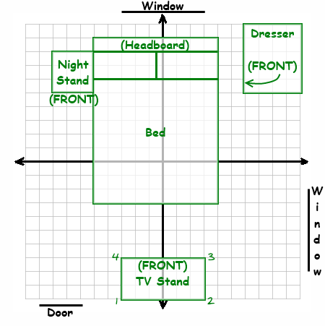

Office (Before)
Find the four corner points of each piece of furniture in the diagram below:
Piece of Furniture | Corner 1 Coordinates | Corner 2 Coordinates | Corner 3 Coordinates | Corner 4 Coordinates
Desk | (-4,10) | (4,10) | (4,6) | (-4,6)
Bookcase | (-10,7) | (-6,7) | (-6,-7) | (-10,-7)
Lamp | (-6,-8) | (-4,-8) | (-4,-10) | (-6,-10)
Chair | (-3,-6) | (2,-6) | (2,-10) | (-3,-10)
Office (Rotation)
Just like the previous two rooms, the Harrisons want to make some updates in the office as well. Mr. Harrison does not like the bookcase in front of the window taking up all the light. He wants to put his desk there, instead. In fact, he seems to just want to shift everything around the room by one wall. Find the four corner points of each piece of furniture in the new layout if they rotate everything around the center of the room counterclockwise by 90 degrees:
Piece of Furniture | Corner 1 Coordinates | Corner 2 Coordinates | Corner 3 Coordinates | Corner 4 Coordinates
Desk | (-10,-4) | (-10,4) | (-6,4) | (-6,-4)
Bookcase | (-7,-10) | (-7,-6) | (7,-6) | (7,-10)
Lamp | (8,-6) | (8,-4) | (10,-4) | (10,-6)
Chair | (6,-3) | (6,2) | (10,2) | (10,-3)


